1. Meng found an error that the previous aboveground biomass rate come from the mean values of “stems > 1m” (Table 3, page 32).

The aboveground biomass data on Blanca’s datasheet were calculated from the biomass rate:

Total Biomass Tonnes CO2e/ha=aboveground biomass (Mg/ha/yr)*44/24

Aboveground biomassg C/m2 = Total Biomass Tonnes CO2e/ha *100*12/44

***[Response from Blanca]*** *Ok. Please use data on table 4 for biomass rate.*

According to Blanca’s response, we confirm that total biomass were from Table 3 and biomass rate were from Table 4.

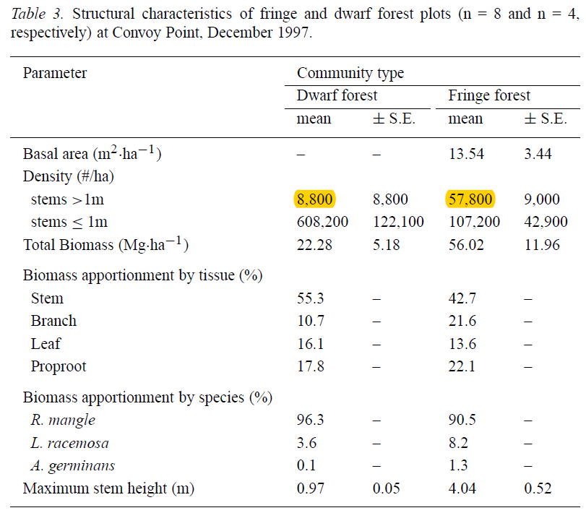

Table 4.

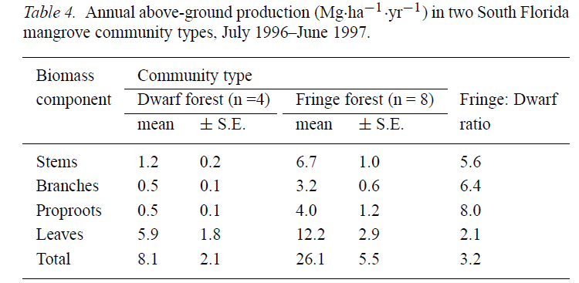

2. According to Blanca’s suggestion, we confirmed that ‘Plant Stature’ should be ‘shrub’ if tree height < 5m. Such information can be found in the page 28. Therefore, Meng updated the stature to ‘shrub’.

